**COMM641   
Assignment 3**

**Part 1**

In this part of the assignment, your goal will be to stylize the basic Vecta Corp. web page using some basic CSS selectors and properties.

**Total: 10 points**

|  |  |
| --- | --- |
| **Point(s)** | **Description** |
| **1** | Use an external style sheet for the placement of all style rules. Place the style sheet into a folder called “styles”. |
| **1** | Using a type selector, set the text of the web page to Arial, Helvetica, sans-serif and size it to 1em. Line height should be adjusted to 2em. Change the background color of the web page to #EDEDED. |
| **1** | Using a type selector, stylize all of the headings. You should change their color and add a 1px #929CA4 border underneath the heading that stretches the length of the web page. |
| **1** | Using a chained set of CSS selectors, select the first letter of the first paragraph and make it 30px. Remember, you will need to select the first paragraph element in the web page and then select the first letter in that paragraph. There are two pseudo-class selectors that you’ll need to use. |
| **1** | Create a class named solution. Stylize this class so that the text is #CC1C0D and the font weight should be bolded. Apply this class to each solution title within the “Our Solutions” section. Do not use additional markup to accomplish this task. It should be done purely in CSS. |
| **1** | Uniquely ID each of the two client testimonials. Call the first one testimonial1 and the second one testimonial2. Using a grouping selector, stylize both paragraphs to be italicized and indented in about 50px. Use the margin property here to accomplish this task. |
| **1** | Link the Module Media text to http://www.modulemedia.com. Then, using an attribute selector, select the <a> element by its href attribute, but only if it has the “http” prefix associated with it. If it does, use the 4 pseudo classes to set the unvisited, visited, active, and hover states to different colors and text decorations. |
| **1** | Using a type selector, remove the bullets from the list in the management team. |
| **1** | Using a pseudo-class selector, select the first item in the management team list and make it blue. |
| **1** | Using a pseudo-class selector, select the last item in the management team list and make it red. |

**Part 2**

In this part of the assignment, your goal will be to build out a slightly more refined version of the Vecta Corp. website so that it uses CSS as much as possible. Add style rules to perform the following tasks using CSS:

**Total: 40 points**

|  |  |
| --- | --- |
| **Point(s)** | **Description** |
| **2** | Use an external style sheet for the placement of all style rules. Place the style sheet into a folder called “styles”. Move the inline style that’s currently attached to the body into this external style sheet as well. Don’t forget to remove the inline style from all 5 pages! |
| **6** | Use CSS selectors where applicable to avoid having to add additional markup, classes, or IDs to the web pages. Unless I explicitly specify it in this document or they have already been added to the beginning files, you shouldn’t add any additional markup, classes, or ids anywhere. |
| **4** | The width of the page should be set to 960px, all text should be Arial, Helvetica, sans-serif, the size of the text should be 1em, and the line height should be adjusted to 2em (double-spaced). |
| **2** | Remove the margins from the top, right, and bottom of the web page. You should only have a left margin of 20px that is carried over from the inline style in the <body> tag. |
| **4** | Adjust the main navigation menu so that it’s spaced correctly and that the list that the navigation menu is in is also formatted to look like my finished design. Pay close attention to the margins/paddings or lack thereof. Also pay attention to the fact that the bullets have been removed from the list. When you begin to build out the Solutions page however, note that the bullets are missing from the navigation menu but remain in the lists within each solution’s description. |
| **2** | Stylize all of the headings on each web page. Colors that you will use here include #DFE3E6 (light grey), #929CA4 (dark grey), and #CC1C0D (red). Note that headings also have a border, curved corners, and a slight padding on the left side of each heading. |
| **2** | Change the color of all your hyperlinks to #CC1C0D (red). |
| **2** | Avoid duplicating property definitions by taking advantage of grouping selectors. |
| **2** | On the main page, pay close attention to the logo images for each solution. Notice how the tops of each image align pretty close to the top of each solution title. Also note that there’s a little space between the text and logo image on the right side of the image. |
| **2** | On the About Us page, you will need to isolate each bio. You can do this by wrapping each bio within its own <section> element. Then stylize that <section> element including the image and paragraphs within each <section> element until you have what I have. |
| **8** | The Pricing page will need quite a bit of modification. You’ll need to take advantage of the <section> element and “pricing” class that I’ve added for you here in order to attach styles to this element. The colors for the dividers on the pricing table are #CC1C0D, #37A4A4, #685288, and #000000. Additionally, you’ll need to wrap each solution/price within a <div> element so you end up with 4 div elements…one for each solution. Remember, you will need to use float in order to get those <div> elements to appear stacked next to one another. |
| **4** | Figure out how to bold the solution titles on the main page. You can’t use classes or IDs to accomplish this. You also can’t use any additional HTML aside from what’s already there. You must use CSS3 selectors to accomplish this task. Add this style rule within an embedded style sheet on the main page…do not put this in your external style sheet. |

**Extra Credit (5 points)**

Redesign the layout of the site so that the navigation menu is on the left side and the content is on the right side. See the graphic mockup below for an idea of what I’m looking for. Do not use tables for this. You will need to add additional markup, add more CSS to structure that markup, and modify existing styles that may break.

|  |  |
| --- | --- |
| **Header (960px)** | |
| **Navigation (220px)** | **Content (740px)** |

**Home Page**

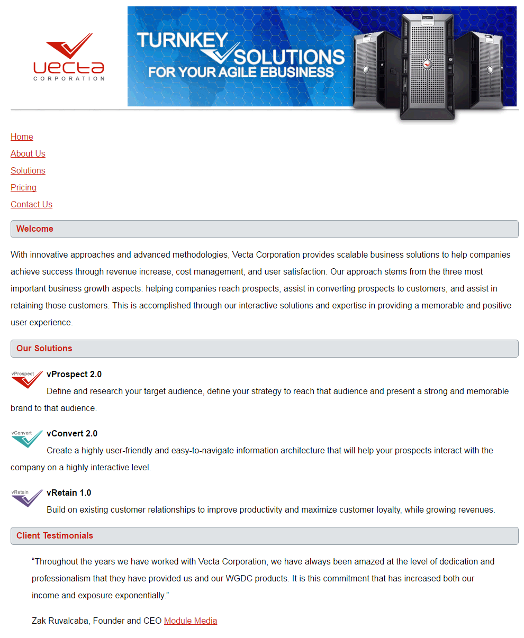

**About Us Page**

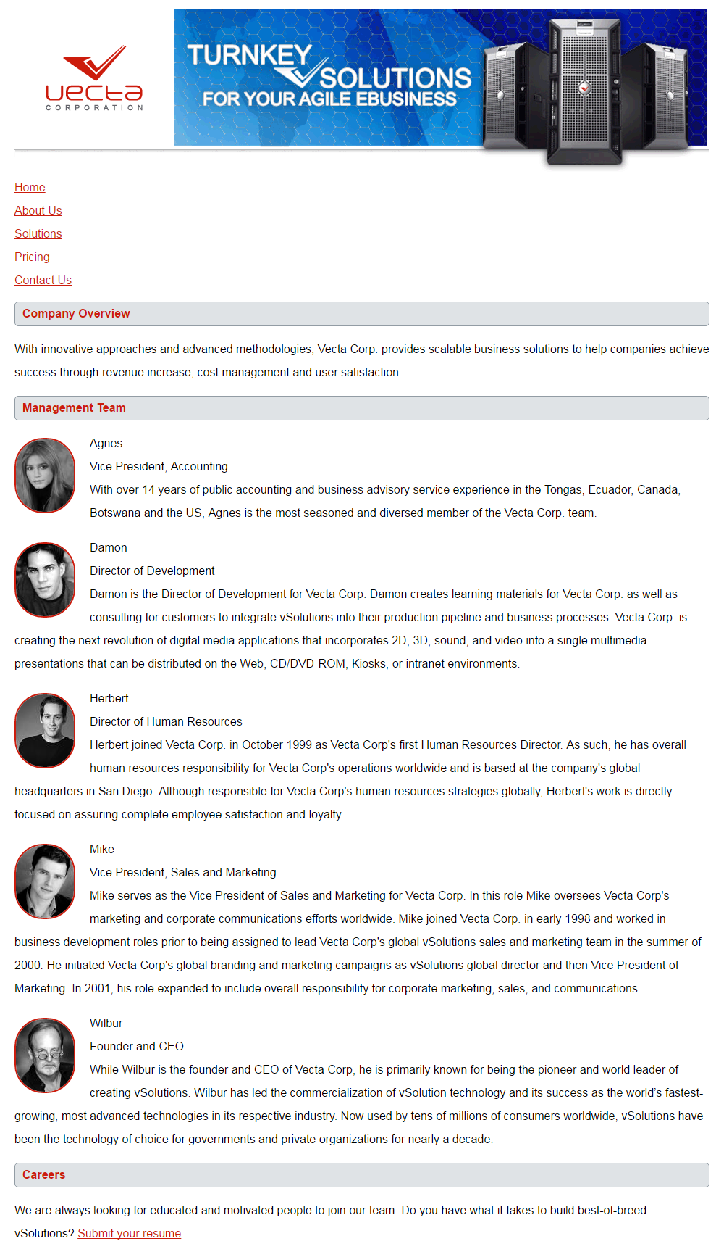

**Solutions Page**

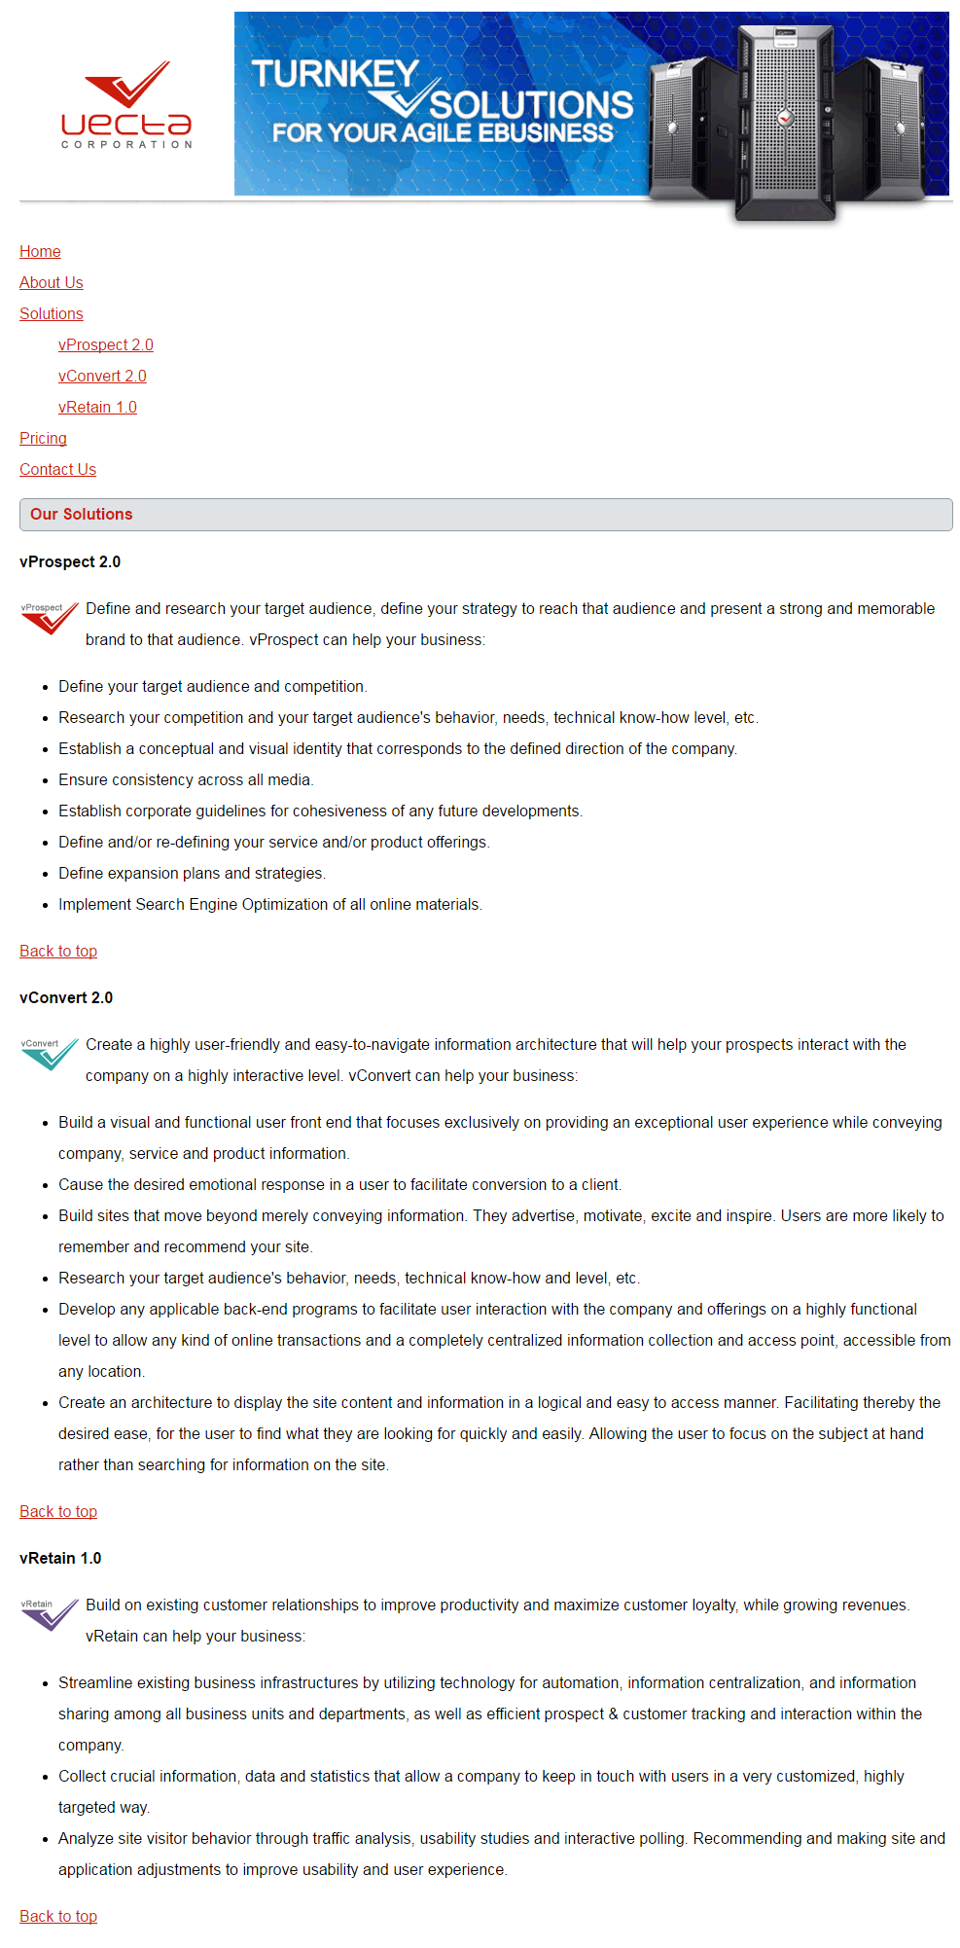

**Pricing Page**

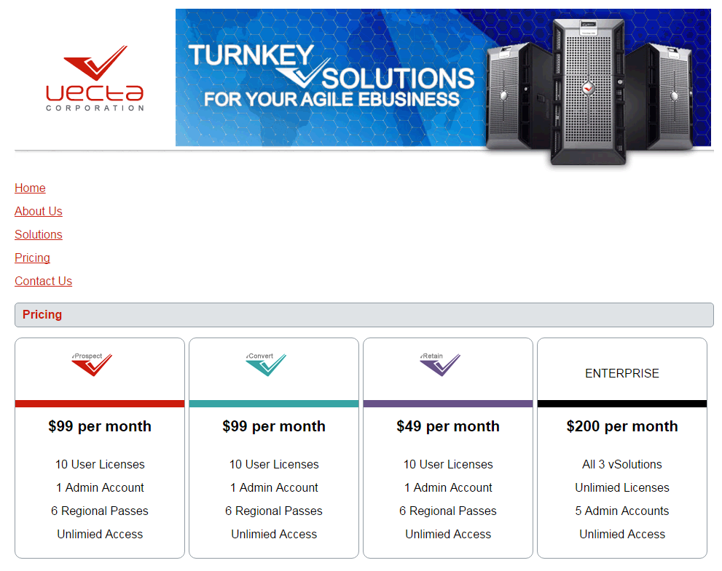

**Contact Us Page**

